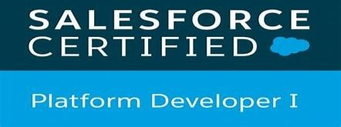 **Ashok D** 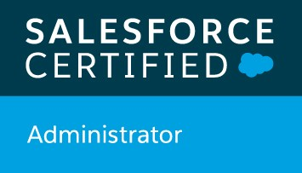

Salesforce Developer

# Mobile No : + 91 - 7702975423

**Email ID : ashokdoddaka69@gmail.com**

# Professional Summary

* Having **3.5** years of experience in SDFC and 1.5 years of experience in LWC.
* Good exposure to all the SFDC Configuration, Customization including APEX TriggerClasses, VF Page, Integration and LWC.
* Experience in salesforce to salesforce and other system integration using VS Code.
* Experienced in User, Role, Profiles Maintenance and permissions.
* Experience on Implementation of Validation Rules, Workflows, Approval Process, Sharing Rules.
* Experience with Implementation of Objects, Custom Apps, Layouts, Tabs, Record Types.
* Have Strong Experience in **Apex, Visual Force, LWC and Apex Data Loader**.
* Have Experience in Data Management, Security Model, Report Generation, Deployment and Security setting.
* Experienced in **LWC and Aura Component**.
* Core competence includes Development, Programming, Coding and testing of software.
* Good knowledge on **Lightning Flow.**
* Good knowledge on Apex bath file and usage of data Loader.
* Good knowledge on dashboard and report generation.
* Ability to handle projects independently in SalesForce.
* Skill on Resource management, Timely Delivery, Handling Stress Situations and always work for "Drive for Results".
* Skills on dealing with Clients, Customers and subordinates.
* Providing KT to the team, leading the team on weekly status meeting with client.
* Mentoring the team on various aspects.
* Maintaining daily status report of the deliverables assigned to the team.
* Good knowledge on Agile methodology and JIRA tools.
* Strong knowledge on Sales, Service and Experience cloud.

**Employment Summary**

# Worked as a Salesforce Developer in Virtusa Pvt Ltd from Nov 2020 to Till now.

**Education Summary**

* **B.Tech (EEE)**  from **JNTU kakinada**.

# Technical Skills Summary

Tools and Packages: :Salesforce

Visual Force Jira

VS Code

Language: Apex

Visualforce pages Java Script/HTML/CSS

LWC

# 

# Projects Summary

**Salesforce Developer Implementation**

Operating System : Windows, MAC

Languages : Salesforce Lightning.

Platform : Visual Studio Code, Jenkins Bit bucket

Customer : **Diamondback Energy (Oil and Gas)**

**Roles and Responsibilities:**

* Creating the Lightning Screen Flow,
* Creating the LWC class to make the flow accept cloning to multiple accounts.
* Developed Salesforce.com workflow, rules and triggers using Apex for updating Users based on Location records.
* Developed Apex Triggers, Apex Classes and Test Methods and other queries.
* Implemented Lightning aura components for Quick actions and Record pages.
* Used Developer console and Visual studio code for development environment.
* Designed and deployed the Custom objects, Custom tabs, Entity-Relationship data model,

validation rules, Workflow Rules, Auto-Response Rules, Page layouts, Components, Visualforce Pages to suit to the needs of the application.

# Salesforce Developer Implementation

Operating System : Windows, MAC

Languages : Salesforce Lightning, Visual Force Platform: visual Studio code, Jenkins, Bitbucket

Customer : **Becton Dickinson (Health Care)**

**Roles and Responsibilities**:

* Creating workflow rule, Connected App.
* Defined lookup and master-detail relationships on the objects and created junction objects to establish connectivity among objects.
* Upgraded some Apps from Salesforce Classic to Lightning Experience to develop rich user interface and better interaction of pages.
* Used SOQL with consideration to Governor Limits for data manipulation needs of the application using platform database objects.
* Implemented Salesforce.com reports as per business requirements.
* Used Data Loader for insert, update, and bulk import or export of data from Salesforce.com subjects. Used it to read, extract and load data from comma separated values (CSV) files.

# Salesforce Developer Implementation

Operating System : Windows 7, MAC OS

Languages : Salesforce classic, Visual Force, Lightning Aura HTML. Platform : force.com

Customer : **centene (Health Care)**

**Roles and Responsibilities**:

* Creating instruction rules for the case. Address field validation.
* Designed, developed and deployed Apex Classes and Apex Triggers for various functional needs in the application.
* Monitoring the application, identified the issues and provide the resolution to business.
* Worked on connecter setup to establish the connection between two salesforce Orgs.
* Used the sandbox for testing and migrated the code to the deployment instance after testing.